* GPS MODULE
* ARDUINO UNO
* GSM MODULE

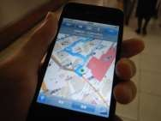NAVIGATION

SYSTEM

CITY DUMP

MANAGEMENT



GARBAGE COLLECTION TRUCKS



GARBAGE

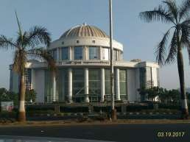

MUNICIPAL

CORPORATION

CENTRAL CLOUD SERVER

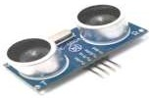

ULTRASONIC

SENSOR